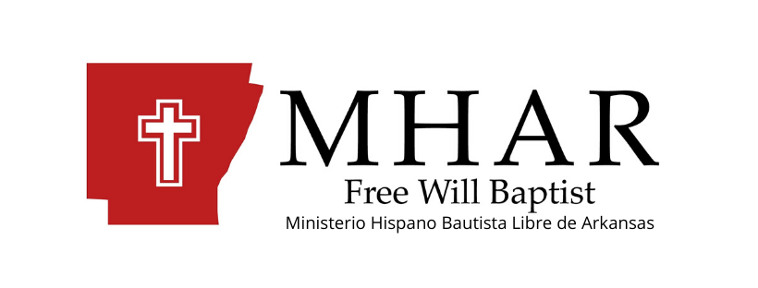
Report 2019
Free Will Baptist Hispanic Ministry of Arkansas

In 2019, our Hispanic ministry advanced by the grace and mercy of our Lord Jesus Christ.
In the church planting area, we had several difficulties but managed to flourish by the grace of God; mainly in the city of Springdale, there we had to move from the place where we started, to the temple of the New Horizon Church where God by his mercy has helped us and after having lost the first members; We got up again and currently we have a congregational group of around 15 brothers and sisters in Christ and their new pastor "Armando Avedo and family".
In North Little Rock, we have Pastor Cesar y Mabel Barrios serving the Lord.
In the City of Dardanelle, we have a New Church with a congregation of 18 people; It is also with his pastor “Juan and Guadalupe Martinez” serving in that city.
In the cities of Russellville and Danville, both churches had a good year, thanks to God’s grace they continue growing.
In the city of Jonesboro, we started with three families about six months ago meeting in a house and after some difficulties we thank God that at least we continue working in Jonesboro, and planning to further strengthen that small work that certainly has a great future.
We also continue with plans to plant new churches in the cities of: Fort Smit, Roger and De Queen. (for the next three years)
Totals: We have today:
- Churches: 6
- Pastors: 6
- Fields recently opened: 1 Jonesboro AR
- Next fields: 3
In the pastoral area we praise and glorify God for his faithfulness. During this year 2019, we strengthened the pastoral relationship, we worked giving seminars and workshops for pastors and we enjoyed the pastoral retreat, where all the pastoral families shared united in prayer, praise, biblical teachings for the pastors, the wives of the pastors and their children and we made work plans for the next years. In this pastoral retreat we also share ministerial experiences to learn and know how to pray for each other and to know how to support each other. We also talked and planed emphasizing the need to reach Hispanic families in our communities and cities. That each local church must multiply as it works on its own growth and edification.
In the area of ​​teaching, training and disciplining, we work strongly locally and generally through the Biblical Institute. We consider this the main column of the ministry. The Institute teaches in the topics of great interest to each Church, since with local training we help the pastor and his congregation with doctrines and topics that are difficult but important for Christians.
The Biblical Institute is key for new leaders, those already established, local missionaries, workers and pastors; since we can have a strong and solid growth of the Hispanic work in the State of Arkansas.
The Biblical Institute has three levels: Basic, Intermediate and Advanced. During 2019, six students completed their Basic level, sixteen completed the intermediate level and soon by the end of 2020 another group of 11 students will complete the Advanced level. (including four brothers of another denomination)
This tells us that in our churches today there are more and better trained teachers, department leaders, and workers, and over the years we will have more churches, more leaders, and more doctrinally solid workers serving and glorifying God in Arkansas.
It only remains for us to tell the Arkansas Free Will Baptist Association; Thank you for all your support, collaboration and prayer, without you it would not have been possible. God has guided you, used you and today our Hispanic Churches and leaders are growing, strengthening themselves to fulfill the call to spread the Kingdom of God throughout Arkansas.
We would like to count on your generous and dedicated hearts for the Arkansas Free Baptist Hispanic Ministry for the years to come.
Thank you.

Missionary. Rolando A. Delgado.
Free Will Baptist Hispanic Ministry of Arkansas.

